BOARD DIRECTOR POSITIONS
Not-for-Profit Employer Representative
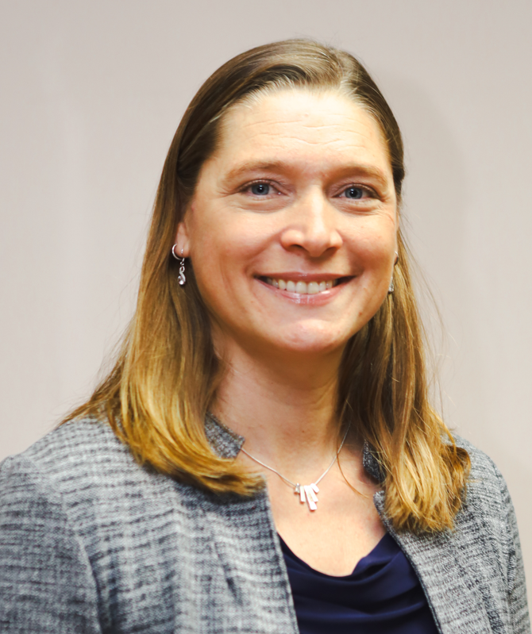  Kathrin McMath  The Broadway Group/Residences for Independent Living | With over 25 years dedicated to senior living healthcare, I've found my life's passion in the rewarding journey of providing housing and care to older adults. After earning my Chartered Professional Accountant designation, followed by a Master of Arts in Healthcare Leadership with a focus on person-centered care in long-term care settings, I've honed my expertise to better serve those in need. Currently blessed to lead The Broadway Group as CEO, I am committed to fostering a culture of excellence and kindness among our staff and community members.  Outside the office, my weekends are filled with adventures in the great outdoors, accompanied by my canine companion, Oaklie. Whether hiking, camping, snowshoeing, or paddle boarding, I find solace and inspiration in nature's beauty. As an avid scuba diver, I'm captivated by the enchanting underwater world of the West Coast, often sharing these experiences with my partner, Dan. Through it all, I've been fortunate to encounter countless caring and compassionate individuals, reaffirming my dedication to the healthcare profession, and aligning professionally and personally with SafeCare’s mandate to promote safety and well-being for those working in the continuing care sector.

At Large Director (Employer – Home Care)
  Noreen Donnelly  Bayshore Home Health | In Noreen’s 20 years’ experience in residential health care, her advocacy of Occupational Health and Safety emerged over the years as she saw firsthand the consequences of staff injuries. Obtaining her Occupational Health and Safety certification from BCIT and becoming a Canadian certified safety professional she continued her quest for injury prevention.  Noreen currently holds a position with a National Healthcare company as their Western Canada’s Health and Safety Business Partner and their mission every day is to get our workers back home safely. She is also a member of SafeCare BC’s TAC since 2019 and proud what the committee has contributed to the advancement of the safety association.  Along with her education and experience she would bring a commitment and understanding for the effective delivery of programs and services promoting and improving workplace safety. She looks forward to working with industry leaders and professionals on the Board at SafeCare BC to implement innovative solutions to these challenges in the role of At Large Director (Employer-Home Care).

REPRESENTATIVE POSITION
Human Resource Services Representative (non-voting)
  Loren Tisdale  Louis Briar Home and Hospital | Loren Tisdelle helps organizations thrive through their most important asset – PEOPLE! He applies an undergrad in Psychology (SFU) with a Global Executive MBA for Healthcare and the Life Sciences (Rotman/UofT) to generate practical and effective business strategies that motivate people, influence decision making and change behaviour. Loren is passionate about delivering creative solutions that have a positive impact on workplace culture, safety and performance.  Loren is currently the Director, Human Resources at Louis Brier Home and Hospital & Weinberg Residence. He is a Chartered Professional in Human Resources (CPHR) with over fifteen years of experience as a healthcare executive. In addition, Loren is an active public speaker and management consultant. He has led organizations to achieve Accreditation with Exemplary Standing (Accreditation Canada) and CARF® Accreditation as well as the Canadian Nonprofit Employer of Choice™ Award. More about Loren can be found at LorenTisdelle.com

